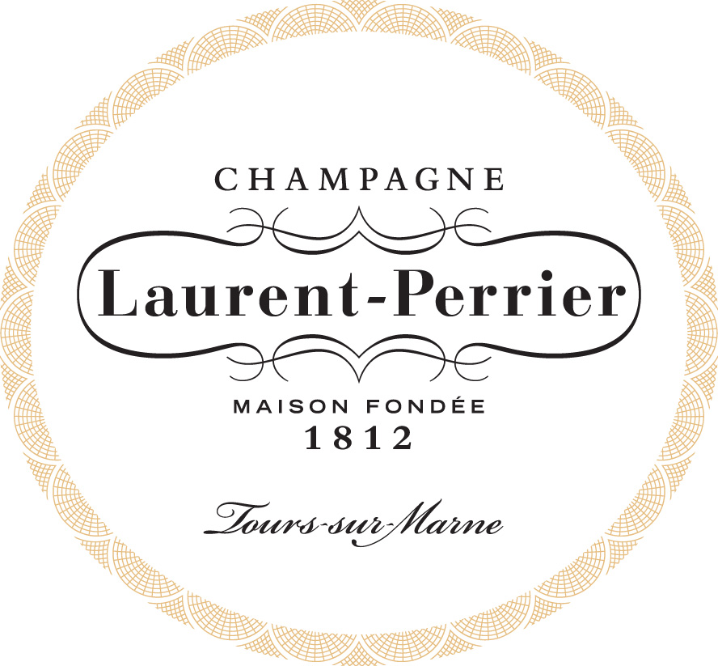

Champagne Laurent-Perrier Women in Wine Leadership Scholarship

New York, NY, May 12, 2020: Women-owned and led, Champagne Laurent-Perrier is delighted to announce the second annual Champagne Laurent-Perrier Women in Wine Leadership Scholarship. The scholarship—inspired by the House’s long history of audacious women leaders both in France and the US, and Winebow’s Women in Wine Leadership Symposium—aims to help advance the next generation of women in wine.

The scholarship is presented to three women expanding their education and skills through the Court of Master Sommeliers—one at each exam level after the Introductory Course. Empowering and personalized mentoring sessions with Michelle DeFeo, President of Laurent-Perrier US and Certified Sommelier, coupled with monetary endowments provide cohesive professional, personal and financial support.

A continuing partnership, the scholarship is awarded by the SommFoundation (The Guild of Sommeliers Education Foundation), a California 501(c)(3) nonprofit corporation. The grant for each exam level is as follows: $1,000 for Certified, $1,500 for Advanced and $2,500 for Master. Applications are now live at: https://www.sommfoundation.com/scholarship/champagne-laurent-perrier-women-in-wine-leadership-scholarship-enrichment-trip/. Submissions are due by 5pm PST on June 26, 2020.

“From sales to marketing and distribution to brand channels, I have been in this business for 20 plus years and I wouldn’t be in my position today if it weren’t for certain people throughout my career reaching out and saying, ‘I believe in you,’ shared Michelle. “This scholarship allows us to connect with three women and say, ‘I believe in you.’”

In 2019, the Champagne Laurent-Perrier Women in Wine Leadership Scholarship was awarded to Elli Benchimol, Wine Director at Joe’s Seafood, Prime Steak & Stone Crab in Washington, D.C. (Master exam), Missy Auge, Sommelier at 71Above in Los Angeles, CA (Advanced exam), and Rosa González, Assistant Manager/Buyer at Packing House Wines in Claremont, CA (Certified exam).

The spirit of this rewarding program celebrates women in the industry. Elli noted that “being a scholarship winner helped remind me that I worked really hard to get here, and being recognized for that is life changing, and a priceless gift of inspiration to never give up!”

The scholarship fosters honest conversations, furthers the community and resources, and creates avenues of growth. “The best part of the mentorship was how candid and lovely Michelle DeFeo was,” Missy revealed. “Many of her words have really stuck, and when I get down, I’m reminded of her advice and guidance. Michelle honestly helped me see a different perspective on former mentors. This was far more than I expected, and I’m so very grateful.”

“Now more than ever, I am moved to have the ability to share stories and experiences, champion emerging women in wine and forge ahead as a collective to further the industry and who leads it,” concludes Michelle.

About Champagne Laurent-Perrier:
Established in 1812, Champagne Laurent-Perrier has a long tradition of cutting edge innovation in the region and can be credited with many of the ideas that have defined Champagne production. The family-owned House focuses solely on Champagne production and has created a style recognized for its freshness, finesse, and elegance. They are the 8th, in the US, and 5th, internationally, largest Champagne brand.

About SommFoundation:
The SommFoundation mission is to assist wine and spirits professionals to achieve the highest level of proficiency and accreditation in the food and beverage industry. The foundation provides enrichment opportunities and scholarships to sommeliers, restaurant professionals, wine journalists, and winemakers to further their knowledge about the world of wine and spirits.

For more information on Champagne Laurent-Perrier, the team
and/or interview requests please contact:

Teuwen Communications
212-244-0622
Marisa Jetter I marisa@teuwen.com
Nicole Horton I nicole@teuwen.com
Stephanie Teuwen I stephanie@teuwen.com

###

